Отчет по практике №4

По ИЗВП

Выполнил студент К17.1

Шишелов Владимир

Задание

Вариант 1

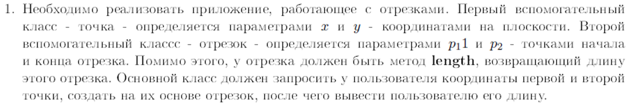

Вариант 5

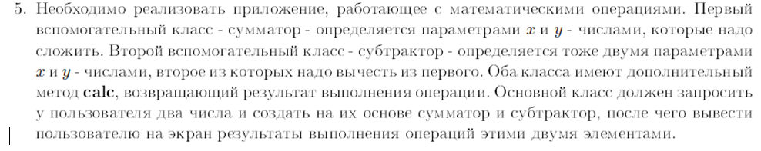

Вариант 10

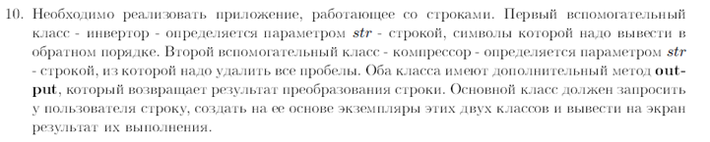

Листинг программы

Class Dot:

package com.company;

public class Dot {

double x; //Variable saves X coordinate

double y; //Variable saves Y coordinate

}

Class Line:

package com.company;

import com.company.Dot; //Connecting class Dot

public class Line {

Dot startPoint = new Dot(); //Creating line start point

Dot finishPoint = new Dot(); //Creating line end point

public Line(double x1, double y1, double x2, double y2){ //Constructor

this.startPoint.x = x1;

this.startPoint.y = y1;

this.finishPoint.x = x2;

this.finishPoint.y = y2;

}

public Line(){ //Default constructor

this.startPoint.x = 0;

this.startPoint.y = 0;

this.finishPoint.x = 0;

this.finishPoint.y = 0;

}

public double length(){ //Function returns line length

return Math.sqrt(Math.pow(finishPoint.y - startPoint.y,2) + Math.pow(finishPoint.x - startPoint.x,2));

}

}

Class Summator:

package com.company;

public class Summator {

double x; //First number

double y; //Second number

public Summator(double firstNum, double secondNum){ //Constructor

this.x = firstNum;

this.y = secondNum;

}

public double calc(){ //Method returns sum x and y

return x+y;

}

}

Class Substractor:

package com.company;

public class Substractor {

double x; //First number

double y; //Second number

public Substractor(double firstNum, double secondNum){//Constructor

this.x = firstNum;

this.y = secondNum;

}

public double calc(){ // Method returns subtraction of x and y

return x-y;

}

}

Class Invertor:

package com.company;

public class Invertor {

String str;

public String reverse(String s){

return str = new StringBuilder(str).reverse().toString();

}

public void output(){

System.out.println(str);

}

}

Class Compressor:

package com.company;

public class Compressor {

String str;

public String compress(String s){

str = s.replaceAll("\\s+","");

return str;

}

public void output(){

System.out.println(str);

}

}

Class Main:

package com.company;

import java.util.Scanner; //Connecting Scanner

import com.company.Line; //Connecting class Line

import com.company.Summator; //Connecting class Summator

import com.company.Substractor; //Connecting class Substractor

import com.company.Invertor; //Connecting class Invertor

public static void main(String[] args) {

Scanner s = new Scanner(System.in);

/\*System.out.println("Enter first dot X");

double startX = s.nextDouble(); //Input first dot X

System.out.println("Enter first dot Y");

double startY = s.nextDouble(); //Input first dot Y

System.out.println("Enter second dot X");

double finishX = s.nextDouble(); //Input second dot X

System.out.println("Enter second dot Y");

double finishY = s.nextDouble(); //Input second dot X

//Assign values

Line l = new Line(startX, startY, finishX, finishY);

System.out.println(l.length()); //Show line length\*/

/\*System.out.println("Enter first number");

double firstNumber = s.nextDouble(); //Input first number

System.out.println("Enter second number");

double secondNumber = s.nextDouble(); //Input second number

Summator sum = new Summator(firstNumber, secondNumber);//Creating class object

Substractor sub = new Substractor(firstNumber, secondNumber);//Creating class object

System.out.println(sum.calc());//Show function calc() result

System.out.println(sub.calc());//Show function calc() result\*/

System.out.println("Enter string");

String str = s.nextLine();

Invertor inv = new Invertor();

inv.str = str;

inv.reverse(str);

str = inv.str;

System.out.print("Reverser string:");

inv.output();

System.out.println("Enter string");

String str1 = s.nextLine();

Compressor com = new Compressor();

com.str = str1;

com.compress(str1);

str1 = com.str;

System.out.print("Compressed string:");

com.output();Демонстрация работы программы

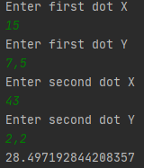

Рисунок 1 – Результат выполнения функций из варианта 1

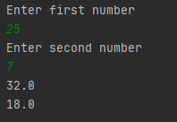

Рисунок 2 – Результат выполнения функций из варианта 5

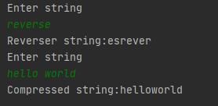

Рисунок 3 – Результат выполнения функций из варианта 10

Выводы:

В данной лабораторной работе мы изучили как работает механизм наследования в Java, научились обращаться к методам базового класса, изучили механизм переопределения методов.